Cyclic Redundancy Check code for polynomial CRC 12
AIM: Write a program to compute CRC code for the polynomial CRC-12
Description:
- In CRC, a sequence of redundant bits, called cyclic redundancy check bits, are appended to the end of data unit so that the resulting data unit becomes exactly divisible by a second, predetermined binary number.
- At the destination, the incoming data unit is divided by the same number. If at this step there is no remainder, the data unit is assumed to be correct and is therefore accepted.
- A remainder indicates that the data unit has been damaged in transit and therefore must be rejected.
The CRC-12 (Cyclic Redundancy Check with a 12-bit checksum) is defined by its generator polynomial. One common generator polynomial for CRC-12 is:
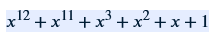
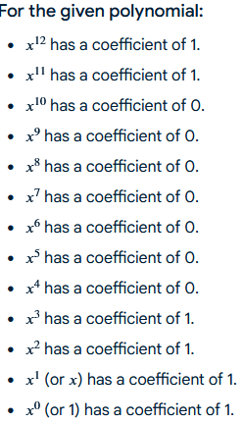
Therefore, the binary representation of this CRC-12 generator polynomial is:
Code : 110000001111
Program:
Program:
#include<stdio.h>
#include<string.h>
char data[50],g[20],temp[20];
void XOR()
{
for(int i=0;i<strlen(g);i++)
temp[i]=(temp[i]==g[i]?'0':'1');

}
void CRC()
{
int i,j;
for(i=0;i<strlen(g);i++)
temp[i]=data[i];
do
{
if(temp[0]=='1')
XOR();
for(j=0;j<strlen(g)-1;j++)
{
temp[j]=temp[j+1];
}
temp[j]=data[i++];

}while(i<=strlen(data));
}
int main()
{
int flag=0,n,m,k;
strcpy(g,"110000001111");
printf("\n Enter data");
scanf("%s",data);
n=strlen(data);
m=strlen(g);
printf("\n Generate polynomial is:%s",g);
printf("length of g is %d length of data is %d\n",m,n);
for(k=n;k<n+m-1;k++)
data[k]='0';

printf("\n Modified datais %s\n",data);
CRC();

printf("\n cyclic redundancy check remainder value us%s",temp);
int j;
for(int k=n,j=0;k<n+m-1;k++,j++)
data[k]=temp[j];
printf("\n Modified code word is:%s",data);
}
OUTPUT:
Enter data10001
Generate polynomial is:110000001111length of g is 12 length of data is 5
Modified datais 1000100000000000
cyclic redundancy check remainder value us00010101010
Modified code word is:1000100010101010

